School Self-Evaluation in SPHE

Towards a Framework for SPHE

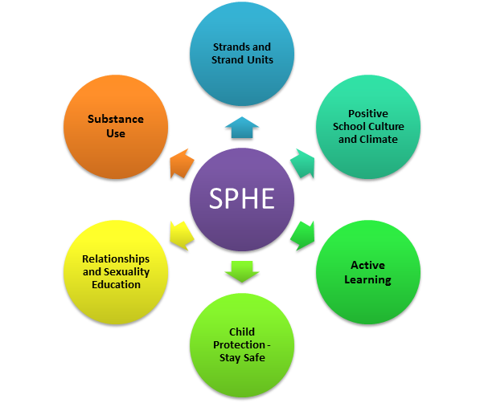

- The Strand Units for SPHE are recommended for delivery across a two year cycle that is implemented across all class levels in the school
- Planning for SPHE should identify the approaches for creating a positive school climate and atmosphere
- Approaches to Assessment in SPHE are implemented across the school
- Active Learning incorporating a variety of strategies is the principal teaching and learning approach to SPHE across all class levels
- A Child Protection Policy is available in the school and, as per Circular 0065/2011, the Stay Safe programme must be fully implemented at all class levels across the school
- An RSE Policy is available in the school and the sensitive areas in RSE are taught across all class levels
- A Substance Use policy is available in the school
- An Anti-Bullying policy is available in the school as per Circular 0045/2013

SPHE Strands and Strand Units

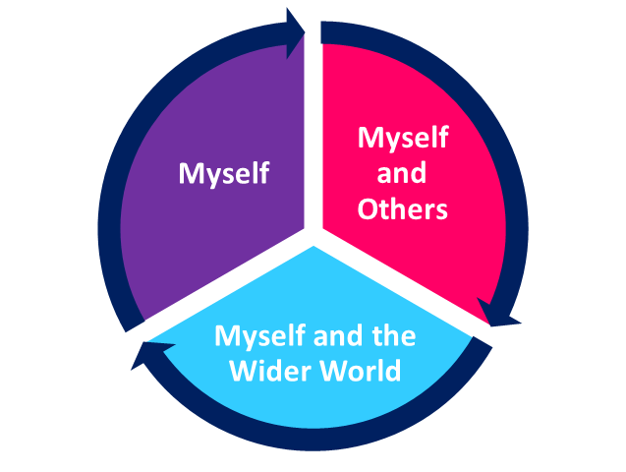
Myself  Self identity  - Self-awareness  - Developing self-confidence  - Making decisions  Taking care of my body  - Health and well-being  - Knowing about my body  - Food and nutrition  Growing and changing  - As I grow I change  - New life  - Feelings and emotions  Safety and protection  - Personal safety  - Safety issues  Making decisions |  | Myself and Others  Myself and my family  My friends and other people  Relating to others
Myself and the Wider Wold

Developing citizenship
- My school community
- Living in the local community
- National, European and wider communities
- Environmental care
Media Education

S.C.O.T. Analysis
Strengths | Concerns
Opportunities | Threats
Reflection Sheet - Aims of the SPHE Curriculum Use as a checklist, a questionnaire, focus group discussion prompts or a self-reflection template for teachers.
Does SPHE provision in our school | ✓ ✕
Promote the personal development and well-being of the child?
How?

Foster in the children a sense of care and respect for himself/herself and others?
How?

Foster in the children an appreciation of the dignity of every human being?
How?

Promote the health of the child and provide a foundation for healthy living in all aspects?
How?

Enable the child to make informed decisions and choices about the Social, Personal and Health dimensions of life both now and in the future?
How?

Develop in the child a sense of social responsibility, a commitment to active and participative citizenship and an appreciation of the democratic way of life?
How?

Enable the child to respect human and cultural diversity?
How?

Enable the child to appreciate and understand the interdependent nature of the world?
How?

SPHE Aims – SPHE Curriculum p9
Broad Objectives of the SPHE Curriculum Use as a checklist, a questionnaire, focus group discussion prompts or a self-reflection template for teachers.
 | When due account is taken of intrinsic abilities and circumstances, what way does our SPHE provision enable the child to | ✓ | ✗
1 | Be self-confident and have a positive sense of self-esteem?
2 | Develop a sense of personal responsibility
3 | Come to understand his/her sexuality and the process of growth, development and reproduction?
4 | Develop and enhance the social skill of communication?
5 | Develop and enhance the social skill of co-operation?
6 | Develop and enhance the social skill of conflict resolution?
7 | Create and maintain supportive relationships both now and in the future?
8 | Develop an understanding of healthy living, an ability to implement healthy behaviour and a willingness to participate in activities that promote and sustain health?
9 | Develop a sense of safety and an ability to protect himself/herself from danger and abuse?
10 | Make decisions, solve problems and take appropriate actions in various personal, social and health contexts?
11 | Become aware of and discerning about the various influence on choices and decisions?
12 | Begin to identify, review and evaluate the values and attitudes that are held by society and to recognise that these effect thoughts and actions?
13 | Respect the environment and develop a sense of responsibility for its long-term care?
14 | Develop some of the skills and abilities necessary for participating fully in groups and in society?
15 | Become aware of some of the individual and community right and responsibilities that come from living in a democracy?
16 | Begin to understand the concepts of personal, local, national, European and global identity?
17 | Appreciate and respect the diversity that exists in society and the positive contributions of various cultural, religious and social groups?
18 | Promote the values of a just and caring society in an age-appropriate manner and understand the importance of seeking trust and peace?
The Key Characteristics of the SPHE Curriculum Use as focus group discussion prompts or a self-reflection template for teachers.
In what way is our SPHE provision in line with the key characteristics as outlined below? |  | Notes
1 | SPHE is a lifelong process that begins before the child comes to school and will continue long after they have left. The emphasis in the primary school is on providing a foundation in SPHE that will inform the child’s actions and decisions and provide a basis for further development.
2 | SPHE is a shared responsibility. The contributions and involvement of parents, teachers, health professionals and members of the community all have a responsibility for the social, personal, and health development of the child. The roles of each should be clear and understood by all.
3 | SPHE is a generic approach. Rather than treating topics in isolation, SPHE aims to develop in the child a generic set of skills, attitudes, values, and understanding relevant to a range of social, personal and health issues. This framework will be supported by specific information as required.
4 | SPHE is based on the needs of the child. It is essential in planning an SPHE programme that priority is given to the needs of the child and cognisance taken of his/her environment. Appropriate adaptations should be made within the curriculum to suit individual requirements and individual school situations.
5 | SPHE is spiral in nature. Similar content is revisited at different stages throughout the child’s time in school. This provides opportunities to consolidate and build on previous learning and allows for issues and topics to be explored and treated in a manner appropriate to the children’s needs, abilities and levels of maturity.
6 | SPHE is developed in a combination of contexts for learning. SPHE in intrinsic to the learning and teaching that occurs both formally and informally in the school. To be effective it should be implemented in a combination of ways through the context of a positive school climate and atmosphere, discrete time and integrated learning.
7 | SPHE requires the children to be engaged in activity-based learning. Children need to be actively engaged in the learning process in order to be able to use what they have learned in a variety of situations. Through active learning children can make sense of what they have learned and take increasing ownership of and responsibility for their own learning.

Audit of Social, Personal and Health Education (SPHE) Plan

Introductory Statement and Rationale
Audit Question | Y | N | Notes
Were staff, parents and BOM consulted and involved in the development of this plan?
Is the vision for SPHE in this school clearly stated?
Do the aims of the school plan reflect our current practice?

Strands and Strand Units
Audit Question | Y | N | Notes
Are the strand and strand units clearly laid out for each class level?
Is the 2 year planning grid/matrix included?
Are the content objectives for each strand unit clearly identified?

Contexts for SPHE
Audit Question | Y | N | Notes
Are the practices for creating a positive school climate and atmosphere identified in the school plan?
Are there any strategies for creating a positive school climate and atmosphere that need to be promoted?
Is discrete teaching time for SPHE timetabled?
Have opportunities for meaningful integration possibilities for SPHE been discussed/addressed?

Approaches/methodologies
Audit Question | Y | N | Notes
In what way is active learning promoted as a key principle of the SPHE curriculum delivery?
Are the following strategies being promoted in the SPHE learning environment:
· Talk and discussion
- Use of photos, pictures and images
- Drama activities
- Written activities
- ICT
- Co-operative games
- Looking at other children’s work

Assessment
Audit Question | Y | N | Notes
Do our Assessment practices related to SPHE take account of
- Teacher Observation
- Teacher Designed Tasks and Tests
- Portfolios and Projects
- Presentation of Children’s work
- Peer Assessment/Self-Assessment

Children with different needs/Equality of participation and access
Audit Question | Y | N | Notes
In what way does our SPHE provision promote inclusion and address children’s needs as appropriate?

Programmes/Policies
Audit Question | Y | N | Notes
Are the programmes used in the delivery of SPHE listed?
Are the following policies present in the SPHE plan:
RSE
Substance Use
Child Protection Guidelines
As per Circular 0065/2011, Is the Stay Safe programme fully implemented at all class levels?
Does homework, if prescribed, reflect the active learning approach in SPHE?
Is the procedure for parental consent for elements of the programmes used in SPHE outlined in the plan and clearly disseminated to all staff?

Resources
Audit Question | Y | N | Notes
Have you a list of all SPHE related resources?
Are people aware of where these are stored and who has responsibility for them?
Is procedure for facilitating guest speakers clearly outlined in this SPHE plan and in line with Circular 0022/2010

Individual Teacher’s planning and reporting
Audit Question | Y | N | Notes
Is this plan used to inform teachers long and short term planning?
Is SPHE progress recorded on a short term basis?

Staff Development
Audit Question | Y | N | Notes
Have staff identified any current training needs in relation to SPHE?
What are their needs?
Have staff been made aware and received of any appropriate SPHE training if available?

Parental Involvement/Community Links
Audit Question | Y | N | Notes
Are strong links forged with parent body/community?

Success criteria
Audit Question | Y | N | Notes
Has criteria for success of this plan been identified?
Have roles and responsibilities for implementation and review been identified?
Has this plan been ratified and communicated to the BOM?

Assessment in SPHE
Audit Question | Y | N | Notes
Is Teacher Observation used as an Assessment Tool in SPHE?

How?

Are Teacher Designed Tasks and Tests used as an Assessment Tool in SPHE?

How?

Are Portfolios used as an Assessment Tool in SPHE?

How?

Are opportunities created for Project Work across the strands of the SPHE Curriculum?

How?

Are displays and presentations of children’s work a feature of Assessment in SPHE?

How?

Teacher Observation for SPHE

Recording the following observations can contribute to the overall picture of the child’s development and can be used as a reference for the teacher when planning for SPHE and in communicating their progress to the child, their parents and to other teachers. (SPHE Curriculum p.73)

Name of Child (initials)
The ability of the child to co-operate and work in groups or to work independently
The informal interactions between the child and adults and between the child and other children
The quality of presentation of work
Particular interests or aptitudes displayed by the child
The participation and interest of the child in a variety of activities
The level of personal or social responsibility exhibited by the child
The reliability of the child in carrying out established routines
The perseverance of the child in carrying out a task
The child’s awareness of the difficulties of others and his/her willingness to help
The questions the child asks and the responses the child makes to questions and suggestions made by the teacher
Various behaviour, for example shyness, leadership ability, level of self-confidence, the tendency to be anxious, sense of fair play, assertiveness, aggression, readiness to take risks and meet challenges
Physical and emotional maturity
The ability of the child to engage in assessing his/her progress and reflecting on his/her learning

Scoring Key: | Excellent | ● | Good | ◐ | Poor | ◌
Audit of Relationships and Sexuality Education

RSE Policy
Audit Question | Y | N | Notes
Is there an up to date RSE policy for the school?
As recommended in the RSE Guidelines, was a committee represented staff, parents and BOM convened to agree this policy?
Has the plan been ratified by the BOM?
Do the aims of the school plan reflect our current practice?

Teaching of RSE in school
Audit Question | Y | N | Notes
Does planning for RSE take account of the content and language to be taught at each class level for the sensitive areas in RSE?
Are the content objectives that address the sensitive issues under Taking Care of My Body and Growing and Changing taught at Junior and Senior Infants?
Are the content objectives that address the sensitive issues under Taking Care of My Body and Growing and Changing taught at First and Second Class?
Are the content objectives that address the sensitive issues under Taking Care of My Body and Growing and Changing taught at Third and Fourth Class?
Are the content objectives that address the sensitive issues under Taking Care of My Body and Growing and Changing taught at Fifth and Sixth Class?
Is the teaching of RSE considered within the overall framework of SPHE in the school?
Are parents communicated with in advance of teaching these lessons? If so, how?
Do parents retain the right to opt their children out of the sensitive areas of RSE I the Curriculum as they may choose?
If so, how is this achieved?
Are the ‘Respect’ Guidelines from the INTO considered and included in the RSE policy of the school?

Approaches/methodologies
Audit Question | Y | N | Notes
Is active learning promoted as a key principle of the RSE curriculum delivery?
Which of the following strategies are used in the RSE learning environment:
Talk and discussion
Use of photos, pictures and images
Drama activities
Written activities
ICT
Co-operative games
Looking at other children’s work
Are the requirements of Circular 0022/2010 taken on board in relation to best practice in SPHE/RSE?

Children with different needs/Equality of participation and access
Audit Question | Y | N | Notes
Does our RSE provision promote inclusion and address children’s needs as appropriate?

Programmes/Policies
Audit Question | Y | N | Notes
Are the programmes used in the delivery of RSE listed?
Is there an overall SPHE policy available in the school?
Is the child protection policy available in the school?

Resources
Audit Question | Y | N | Notes
Have you a list of all RSE related resources?
Are people aware of where these are stored and who has responsibility for them?
Is procedure for facilitating guest speakers clearly outlined in this RSE plan?

Individual Teacher’s planning and reporting
Audit Question | Y | N | Notes
Is the RSE plan used to inform teachers long and short term planning?

Staff Development
Audit Question | Y | N | Notes
Have staff identified any current training needs in relation to RSE?
Have staff been made aware and received of any appropriate RSE training if available?

Success criteria
Audit Question | Y | N | Notes
Has criteria for success of this plan been identified?
Have roles and responsibilities for implementation and review been identified?
Has this plan been ratified and communicated to the BOM?

School Planning for SPHE
Appropriate strategies for creating a positive school climate and atmosphere

Building effective communication within the school | Strength | Needs attention | Comment
Children have ways to voice their concerns
Children are listened to (student council)
There are various forms of staff communication in place.
Parents are welcomed and listened to in the school
Visitors are invited and welcomed
Catering for individual needs
The curriculum is adapted to suit various needs, interests and concerns
The curriculum deals with the specific environment in which it is placed
Creating a health promoting physical environment
Basic physical needs For example, heat, light and ventilation are met
There are appropriate facilities for playing and eating
The building and its environs are safe and promote a sense of security and create an atmosphere that fosters living in a healthy way
Children care for and respect the wider environment as they share responsibility for taking care of their own immediate physical surroundings?

Developing democratic processes
The welfare of each individual is fostered and concerns of all taken into account?
The rules are negotiated
Responsibility is shared
Everyone in the school community feel a sense of belonging
Events are held which give children a sense of community and increase their sense of belonging
Enhancing Self -esteem
The school plans for a consistent approach to enhancing the self-concept and self-esteem of all its community
There are there structures and approaches within the school that reflect interest in all the children
There are opportunities for each child to succeed, to develop individual talents and to acquire a realistic picture of his/her own strengths and limitations
The school expectations of children are positive and realistic
New children and their parents are welcomed to the school
There are structures to support children when they are upset
There are opportunities to affirm the work of members of the staff and provide whole school in career development?
There are opportunities to celebrate achievements?
Fostering respect for diversity
The Children are treated in a fair and just way
Children experience respect for diversity
Issues of inequality are dealt with and addressed
Strengths of individual children are fostered
Children are encouraged to listen to different points of view
Children learn about different cultures and explore different traditions
Fostering inclusive and respectful language
Language that is promoted in the school nurtures both children and adults as unique and valuable human beings
The language of the school encourages inclusiveness
Children treat each other appropriately when playing together
Developing appropriate communication between home and school
There are effective strategies for dialogue between teachers and parents
The school ensures clarity of language in any form of written communication from the school
Developing a whole school approach to assessment
There is agreement on the role of assessment in SPHE, the tools to be used and how this will be communicated
Self-assessment is promoted

SPHE Curriculum Teacher Guidelines p.23

Identifying strategies
for creating a positive climate in our school
(See Teacher Guidelines page 22)

Prioritise three of the strategies below. Identify one you are already implementing, one you would aim to implement in the short term and one in the longer term. Reflect on what you might do to progress these aims both as a whole staff and as an individual member of staff.

Building effective communication within the school
----------------------------------------------------------------------------------------------------------------------------------------------------------------------------------------------------------------------------------------------------
Catering for individual needs
------------------------------------------------------------------------------------------------------------------------------------------------------------------------------------------------------------------------------------------------------------------------------------------------------------------------------------------------------------------------------
Creating a health promoting physical environment
------------------------------------------------------------------------------------------------------------------------------------------------------------------------------------------------------------------------------------------------------------------------------------------------------------------------------------------------------------------------------
Developing democratic processes
------------------------------------------------------------------------------------------------------------------------------------------------------------------------------------------------------------------------------------------------------------------------------------------------------------------------------------------------------------------------------
Enhancing self-esteem
------------------------------------------------------------------------------------------------------------------------------------------------------------------------------------------------------------------------------------------------------------------------------------------------------------------------------------------------------------------------------
Fostering respect for diversity
------------------------------------------------------------------------------------------------------------------------------------------------------------------------------------------------------------------------------------------------------------------------------------------------------------------------------------------------------------------------------
Fostering inclusive and respectful language
------------------------------------------------------------------------------------------------------------------------------------------------------------------------------------------------------------------------------------------------------Developing appropriate communication between home and school
-------------------------------------------------------------------------------------------------------------------------------------------------------------------------------------------------------------------------------------------------------Developing a whole school approach to assessment
-------------------------------------------------------------------------------------------------------------------------------------------------------------------------------------------------------------------------------------------------------See Table A: Key Elements of a positive school culture and climate (DES Anti-Bullying Procedures 2013)

Area of Focus | Y/N Comment
The school acknowledges the right of each member of the school community to enjoy school in a secure environment.
The school acknowledges the uniqueness of each individual and his/her worth as a human being.
The school promote positive habits of self-respect, self-discipline and responsibility among all its members.
The school prohibits vulgar, offensive, sectarian or other aggressive behaviour or language by any of its members.
The school has a clear commitment to promoting equity in general and gender equity in particular in all aspects of its functioning.
The school has the capacity to change in response to pupil’s needs.
The school identifies aspects of curriculum through which positive and lasting influences can be exerted towards forming pupils’ attitudes and values.
The school takes particular care of ‘at risk’ pupils and uses its monitoring systems to facilitate early intervention where necessary and it responds to the needs, fears or anxieties of individual members in a sensitive manner.
The school recognises the need to work in partnership with and keep parents informed on procedures to improve relationships on a school-wide basis.
The school recognises the role of parents in equipping the pupil with a range of life-skills.
The school recognises the role of other community agencies in preventing and dealing with bullying.
The school promotes habits of mutual respect, courtesy and an awareness of the interdependence of people in groups and communities
The school promotes qualities of social responsibility, tolerance and understanding among all its members both in school and out of school
Staff members share a collegiate responsibility, under the direction of the Principal, to act in preventing bullying/aggressive behaviour by any member of the school community

Pupil Voice in SPHE

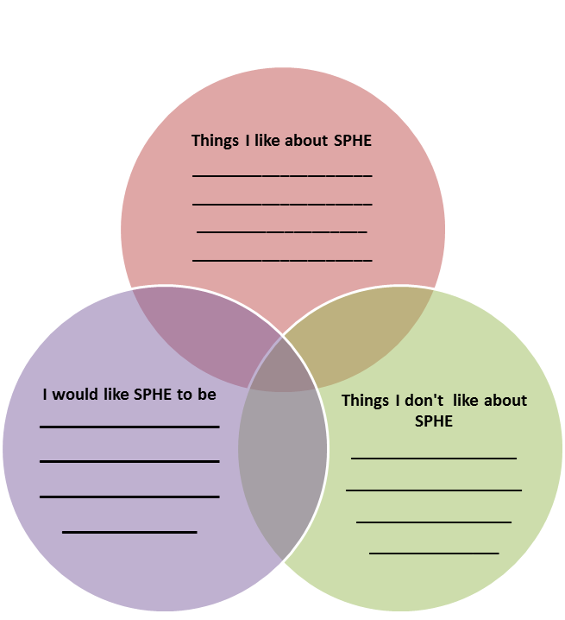

SPHE Pupil Focus Group Questions

1. What is SPHE?

2. Do you like SPHE? Why/Why not?

3. What do like most about SPHE?

4. What do you like least about SPHE?

5. Is SPHE different in any way to your other subjects? Is so, in what way?

6. Is there anything else that you would like to include in SPHE classes?

7. What are you favourite activities in SPHE lessons?

8. Do you ever talk to your parents/ caregivers at home about SPHE?
Why/Why not?

9. If you were to give a friend 3 pieces of advice about SPHE, what would they be?

10. If you were to give a teacher 3 pieces of advice about SPHE, what would they be?

Audit of SPHE Resources

Name of Resource | Topics Covered | Class Suitability

The SPHE Resource list that accompanies this document and that is available on www.pdst.ie may support you in completing this audit!

TEACHING STAFF QUESTIONNAIRE - SSE of SPHE
1 | How would you rate the importance of SPHE in the curriculum?
🔳 Very important 🔳 Somewhat important 🔳 Not important
2 | Do you follow the school SPHE plan in your planning for SPHE?
🔳 yes 🔳 no
3 | Do you feel that a Year 1/Year 2 approach would work better in implementing SPHE in our school?
🔳 yes 🔳 no
4 | How much time to you devote to SPHE each week?
5 | List our two greatest strengths in this school in relation to the teaching of SPHE.
1.
2.
6 | How would you rate the resources available for SPHE?
🔳 Very satisfactory 🔳 Satisfactory 🔳 Not satisfactory
7 | List your two biggest obstacles to teaching SPHE.
1.
2.
8 | What area of SPHE do you feel needs more focus?
9 | Would you like to avail of any CPD in any particular area of SPHE?
10 | How do you feel we could enhance the positive school climate and atmosphere in this school?
Any further suggestions?

Sample SSE of SPHE Letter and Questionnaire for Parents

Scoil X
School Self-Evaluation Questionnaire for Parents
Social, Personal and Health Education

Dear parent(s) and guardian(s),

We are undertaking a self-evaluation of teaching and learning in SOCIAL, PERSONAL and HEALTH EDUCATION (SPHE) in our school.

The SPHE Curriculum aims to enable children to develop a framework of skills, attitudes, values and knowledge that will inform their actions and decisions in
- their personal development;
- their health and well-being;
- the creation and maintenance of supportive relationships;
- becoming active and responsible members of society.

To help us with this evaluation, we would be very grateful for your views and opinions on the matters detailed in the questionnaire below. The questionnaire should take between 10 and 15 minutes to complete. We would be very grateful if you would complete it and return it to the school before xxxx. Please note that you may complete the questionnaire anonymously and that all individual responses will be treated confidentially.

Many thanks,
Principal
Date

Please tick the correct box: | Junior Infants | Senior Infants | 1st Class | 2nd Class | 3rd Class | 4th Class | 5th Class | 6th Class
My child is in | o | o | o | o | o | o | o | o

 | Please tick the correct box: | Strongly Agree | Agree | Don’t Know | Disagree | Strongly Disagree
1 | My child enjoys SPHE lessons | o | o | o | o | o
2 | My child is doing well at SPHE | o | o | o | o | o
3 | I often ask my child about SPHE lessons | o | o | o | o | o
4 | I am familiar with the various themes within SPHE as per the curriculum | o | o | o | o | o
5 | I feel that SPHE is a priority learning area for my child | o | o | o | o | o
6 | I know my child’s strengths in SPHE | o | o | o | o | o
7 | My child gets weekly SPHE related homework | o | o | o | o | o
8 | I feel that SPHE is taught as a priority area in my child’s school | o | o | o | o | o
9 | I often receive information about what my child is learning in SPHE | o | o | o | o | o
10 | I feel the school should do more to make parents aware of what SPHE is and why we teach it | o | o | o | o | o
11 | I feel that there is a positive climate and environment in this school | o | o | o | o | o

Is there any way that the school could help you to help your child with Social Personal and Health Education?

Is there any way that the school can improve its approach to Social, Personal and Health Education?

Any other comments or suggestions?

Thank you for completing this questionnaire

SSE of SPHE Parent Questionnaire
Adapted from SPHE in the Primary School - Inspectorate Evaluation Studies Report 2009
 | Please tick the correct box: | Strongly Agree | Agree | Don’t Know | Disagree | Strongly Disagree
1 | I am aware of the school’s plan for SPHE | o | o | o | o | o
2 | I am familiar with the work my child does at school about personal safety | o | o | o | o | o
3 | I am familiar with the work my child does at school about co-operating with others | o | o | o | o | o
4 | I am familiar with the work my child does at school about healthy eating and exercise | o | o | o | o | o
5 | The school promotes healthy eating | o | o | o | o | o
6 | I support the school’s policy on healthy eating | o | o | o | o | o
7 | I sometimes follow up on my child’s SPHE work at home | o | o | o | o | o
8 | I am aware of the school’s policy on Relationships and Sexuality Education | o | o | o | o | o
9 | The Relationships and Sexuality Education programme is being implemented in my child’s school | o | o | o | o | o
10 | I support the approach the school takes to teaching my child about relationships and sexuality | o | o | o | o | o
11 | I would feel comfortable approaching the school to talk about the school’s SPHE programme, including relationships and sexuality | o | o | o | o | o
12 | I support the approach the school takes to teaching my child about Child Abuse Prevention through the Stay Safe Programme | o | o | o | o | o
13 | I support the approach the school takes to teaching my child about bullying | o | o | o | o | o

I would like the school to share more information about
⬜ The School SPHE plan ⬜ Child Abuse Prevention ⬜ Stay Safe ⬜ Anti-Bullying procedures ⬜ Relationships and Sexuality Education ⬜ Healthy Eating ⬜Physical Activity and Physical Education ⬜ Internet Safety ⬜ Safety and Protection (Farm Safety, Fire Safety, Water Safety) ⬜ Human Rights Education ⬜ Other (please specify) ________________________

SPHE Pupil Focus Group Questions

- What is SPHE?

- Do you like SPHE? Why/Why not?

- What do like most about SPHE?

- What do you like least about SPHE?

- Is SPHE different in any way to your other subjects? Is so, in what way?

- Is there anything else that you would like to include in SPHE classes?

- What are you favourite activities in SPHE lessons?

- Do you ever talk to your parents/ caregivers at home about SPHE?
Why/Why not?

- If you were to give a friend 3 pieces of advice about SPHE, what would they be?

- If you were to give a teacher 3 pieces of advice about SPHE, what would they be?

Teacher Focus Group discussion
Focus group participants |  | Class(es) taught
SSE of Social Personal and Health Education
Topic | Key questions | Main points made
SPHE planning | - What are the positives in relation to our planning in Social, Personal and Health Education?  - What are our concerns?  - How can we improve/suggestions to support teachers?
SPHE teaching | - What are our strengths in relation to the teaching of Social, Personal and Health Education in?  - What are our concerns?  - How can we improve?
SPHE Professional Development | - How can we improve on upskilling our staff in SPHE? (CPD courses/Croke Park Hour presentations/lesson modelling)
SPHE Resources | - How satisfied are you with the resources available to you for the teaching of SPHE?  - Are you aware of any good SPHE resources that you would like the school to invest in?  - How can we improve on our resources in SPHE? (equipment, DVDs, books, posters etc)
Any other comments/suggestions?

Further surveys/questionnaires available from the following sources:
NEPS A Continuum of Support Guidelines
My thoughts about school questionnaire (page 97)
Wellbeing in Primary Schools
10 Actions a school can undertake to promote the wellbeing of the school community (page 34)
Mental Health Promotion Self Evaluation Questionnaire for staff and parents/guardians (page 35)
Mental Health Promotion Self Evaluation Questionnaire for staff and parents/guardians (page 41)
SPHE in the primary school - Inspectorate Report 2009
The Children's Happiness Scale
Schools for Health in Ireland (Primary) Framework
Schools for Health in Ireland (Primary) Coordinators Handbook
Action Planning Guidelines and Template (page 22)
NBSS Learning Environment Checklist
School Self Evaluation sample questionnaires, interview schedules, Action Plans and School Improvement Plans from www.schoolselfevaluation.ie

Teacher Reflection on Active Learning Methodologies
- Where are you now in terms of present teaching/learning practice

- What is your motivation behind integrating active learning methodologies and teaching methods into your existing classroom practice?

- How can you build on your existing practice?

- What do you hope to achieve?

