When selecting any resources for SPHE, ensure that they are selected in keeping with the ethos of the school and the SPHE plan. Refer to p. 103 of the Teacher Guidelines for sample criteria for choosing resources.

Core Resources for SPHE
Name of resource | Brief description | Contact details
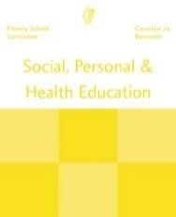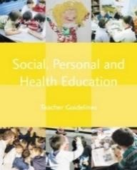 | SPHE Curriculum SPHE Teacher Guidelines | National Council for Curriculum and Assessment www.ncca.ie
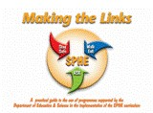 | Making the Links  Making the Links is a guide to using materials from the Walk  Tall programme, the  Relationships and Sexuality  Education programme and the  Stay Safe programme. It is a practical guide in assisting teachers in their planning for SPHE. | PDST  14 Joyce Way,  Park West Business Park,  Nangor Rd, Dublin 12   01-4358587  info@pdst.ie
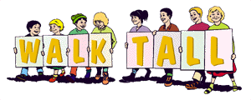 | Walk Tall  The Walk Tall supports the prevention of substance  misuse and aims to give  children the confidence, skills and knowledge to make healthy choices. | PDST  14 Joyce Way,  Park West Business Park,  Nangor Rd, Dublin 12   01-4358587  info@pdst.ie
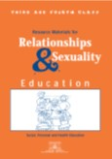 | Relationships and  Sexuality Education (RSE) Manuals  The RSE manuals facilitate the teaching of Relationships and Sexuality education. | PDST  Health and Wellbeing administrator  C/O Co. Wexford Education Centre  Milehouse Rd, Enniscorthy,  Co. Wexford   053 9239105   healthandwellbeing@pdst.ie
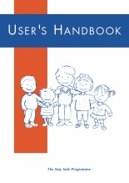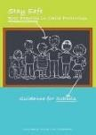 | Stay Safe  The Stay Safe programme is a personal safety skills  programme for schools; its  overall objective is to prevent  child abuse and other forms of  child victimization (also Stay  Safe Best Practice in Child Protection guidelines) | Child Abuse Prevention  Programme,  Bridge House,  Cherry Orchard Hospital,  Dublin 10   01-6206347  staysafe@pdst.ie

Additional Resources for SPHE

Further resources published by the Substance Misuse Prevention Programme (Walk Tall) include:

Resource | Brief description | Contact Details
Best Practice guidelines in substance misuse prevention education | This booklet provides information on and consolidates the use of best practice guidelines in the delivery of substance misuse prevention education in primary schools. It supports schools in formulating their substance use policy | All resources from the  Substance Misuse  Prevention Programme available from:
Understanding substances and substance  use | A handbook for teachers drawing on the highly valued materials available to primary and post primary schools | PDST  14 Joyce Way,  Park West Business Park,  Nangor Rd,  Dublin 12   01-4358587 info@pdst.ie
Circle Time/ Am Ciorcail DVD | This DVD was developed as a resource to encourage and enhance the use of Circle Time as an active learning strategy in the classroom.
What is a drug DVD (6th class lesson) | This DVD was developed as a resource for teachers to support and model the teaching of the knowledge component (drugs lessons) in the Walk Tall programme

Further resources available from the RSE office include:

Name of resource | Brief description | Contact details
Resource pack for  RSE in primary schools | A resource to support teachers in policy development and in teaching the sensitive content of the RSE lessons at the various class levels
All resources are available from:

PDST
Health and Wellbeing administrator
C/O Co. Wexford Education Centre
Milehouse Rd,
Enniscorthy,
Co. Wexford
 053 9239105 healthandwellbeing@pdst.ie

See also the PDST website www.pdst.ie under SPHE
Resource list for Primary Schools | Additional resources that may support schools in the  implementation of the RSE programme
Resources for students with learning difficulties | Resource lists and differentiation templates to support teachers in implementing the content of the sensitive lessons
Interim curriculum and guidelines for primary schools | Provides an overview of the content of RSE for all class levels and addresses considerations for planning and implementing RSE

Further resources available from the Child Abuse Prevention Programme (Stay Safe) include:

Name of resource | Brief description | Contact details
Stay Safe for children with learning difficulties | A resource to assist teachers in introducing personal safety skills to children in special education. | All resources are available from:  Child Abuse Prevention  Programme,  Bridge House,  Cherry Orchard Hospital,  Dublin 10   01-6206347 staysafe@pdst.ie
Stay Safe –A Parent’s Guide | In booklet and DVD format to introduce the Stay Safe programme to parents and  outline the topics in the programme
Stay Safe CD | A CD of songs to accompany the Stay Safe programme
Stay Safe DVD | A dvd to accompany the  topics of the Stay Safe programme

Various other resources
These resources can be used to support teaching of SPHE in the classroom in line with your whole school plan for SPHE.

Resource | Brief description | Contact details
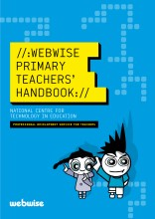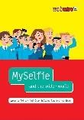 | Webwise  The webwise programme has been specifically designed for teachers who wish to introduce internet safety into their teaching of the SPHE Curriculum. This  programme compliments and extends the  messages of the Stay Safe programme. NEW Anti-cyber-bullying teaching resource: #myselfie | PDST Technology in Education,  Dublin City Universuty,  Dublin 9   01 7008200  Online at www.webwise.ie
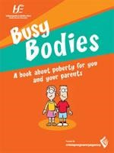 | Busy Bodies  Busy Bodies Adolescent Development  Programme provides information on the physical and emotional changes that  children may experience during puberty.  Busy Bodies was developed to support the teaching of the 5th and 6th class component of Relationships and Sexuality Education  (RSE) within the context of Social Personal and Health Education. | To order a free copy of the DVD and student copies of the booklet,  teachers need to register as a  professional on healthpromotion.ie or follow this link:  http://www.healthpromotion.ie/pub lication/fullListing?category=&search  HSE=busy+bodies
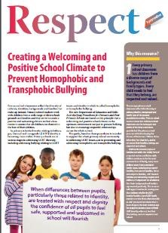 | Respect Guidelines  The Respect Guidelines were launched by the Minister of Education Jan O’Sullivan to assist schools in creating a welcoming and  positive school climate and help primary  teachers to address homophobic and  transphobic bullying | http://www.glen.ie/attachments/INT  O_GLEN_Primary_Teachers_Resourc  e.pdf
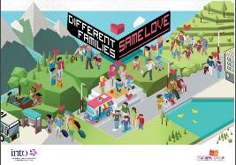 | Different Families, Same Love Poster  Different Families - Picture Book Lessons (GLEN)  List of picture books that support inclusion  (INTO) | Different Families, Same Love Poster  Different Families Picture Book  Lessons  Picture Books for Inclusion (INTO) Other Useful Resources (INTO)
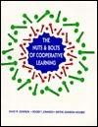 | The Nuts and Bolts of Cooperative Learning  A practical guide to using cooperative learning in the classroom. | Johnson, Johnsoon and Hollubec

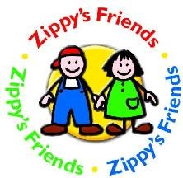 |  |  | Zippy’s Friends  A programme for five to seven year olds which improves the abilities of young children to cope with difficulties and develops social skills and assertiveness | Health Service Executive Mary Kilraine Hannon,  Health Promotion Officer,  HSE Service, West City Centre,  Seamús Quirke Rd, Galway mary.kilrainehannon@hse.ie
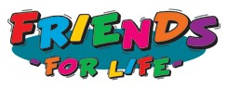 |  |  | Friends for Life  This programme is a school-based positive mental health programme that helps  students to develop effective strategies to deal with worry, stress and change and  teaches the skills required to reduce anxiety and promote resilience. | Check your local Education Centre for a Friends for Life course in your  area
 |  |  | The Incredible Years | www.incredibleyears.com
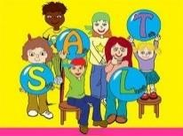 |  |  | Stop, Ask, Listen, Talk (SALT)  Through the S.A.LT. programme, children will learn what conflict is, what it feels like to be in conflict and how to negotiate  effectively to create a better outcome for  themselves and others | Available to purchase from :  Drumcondra Education Centre  Dublin 9   01 8576400 info@ecdrumcondra.ie
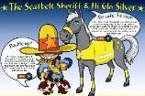 |  |  | Be Safe  Be Safe’ is an activity- based resource pack on road safety, fire safety and water safety.  Seatbelt Sherrif and Hi Glo Silver  These initiatives encourage children to become ambassadors for wearing seat-belts and hi-viz clothing. | Research and Education unit  Road Safety Authority,  Moy Valley Business Park,  Primrose Hill, Ballina, Co. Mayo   1890 50 60 80 education@rsa.ie
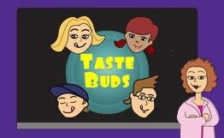 |  |  | Taste Buds  A resource aimed at children aged eight to ten years and aims to help children enjoy  learning about the origins and production of food and the importance of eating a balanced diet and physical activity | Safefood   1850 40 45 67   www.safefood.eu
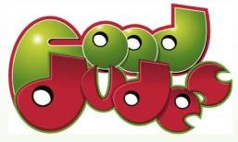 |  |  | Food Dudes  Food Dudes is a programme that encourages children to eat more fruit and  vegetables both in school and at home. It is based on positive role models (the Food  Dudes characters), repeated tasting and rewards. | www.fooddudes.ie
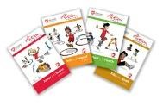 |  | Action for Life  Volume 2  A physical activity programme for all class levels with health related activities to support SPHE. |  | Irish Heart Foundation  50 Ringsend Rd, Dublin 4   01 6685001   eflannery@irishheart.ie
 |  | Bí Folláin  A programme to support social, personal and health education in primary schools. |  | Curriculum Development Unit,  Mary Immaculate College,  South Circular Rd,  Limerick   061 204300
 | 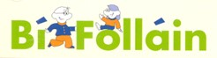
School Work’s |  | A resource pack on the three interlinking issues of child labour, the right to education and fair-trade set in the context of  Nicaragua with a set of support photographs |  | INTO  Vere Foster House,  35 Parnell Square, Dublin 1   01-8047700  info@into.ie
Working Together for Positive Behaviour A guide for teachers and schools |  | This resource explores the nature of behaviour and outlines a process by which  teachers and others who work with children in schools can develop approaches to  behaviour which work well and maximise the potential of the learning environment  for all |  | Curriculum Development Unit,  Mary Immaculate College,  South Circular Rd,  Limerick   061 204300
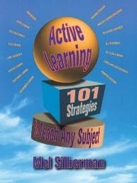 |  | Active Learning  101 Strategies to Teach Any Subject Fresh ideas and innovative strategies to make learning active, with clear step-bystep instructions. |  | Mel Silberman

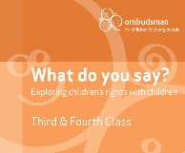  What do you say? | What do you say? Exploring children’s rights with children consists of activities  that explore issues relating to children’s  rights. It contains references to rights in the  UN Convention on the Rights of the Child and the Constitution. | Ombudsman for Children Office  Millennium House  Strand Street Great,  Dublin 1   01 8656800
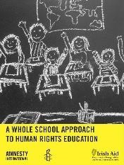  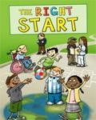  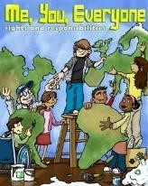  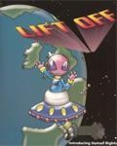  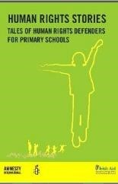 | Human Rights Education: The whole school approach  This resource provides practical suggestions for principals and teachers interested in taking a whole school approach to human rights education.  The Right Start is designed for use with  Junior Infants to Second Class and is focused on developing the skills of empathy,  communication, cooperation, respect and responsibility and conflict resolution.  Me, You, Everyone is designed for use with third and fourth class. It focuses on  knowledge of human rights issues while also building on the human rights skills and attitudes fostered and developed in “The Right Start”.  Lift Off is designed for use with fifth and sixth class. It again focuses on knowledge of  human rights issues while further fostering and developing  the skills and attitudes acquired from the previous resources.  Human Rights Stories provides five tales of human rights defenders, written in a version for older and younger learners. The  resource includes a range of curriculum links, lesson activities, class questions,  worksheets and teacher's notes. Engaging  with the stories through discussion, creative thinking and character exploration can  support the development of literacy.  Through the medium of storytelling, human rights situations can be explored on a  level which children can encounter the real life impact of human rights in practice. | All resources for Human Rights Education available from:  Amnesty International Ireland  Sean McBride House  48 Fleet Street,  Dublin 2  Caitlin Lewis   01-8638317 hre@amnesty.ie www.amnesty.ie
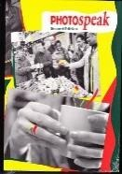 | Photospeak  A resource bank of black and white photographs to support use of this methodology in the curriculum. | Partners in Faith  14K Fatima Mansions,  Rialto,  Dublin 8   01 4535348 info@partnersinfaith.ie
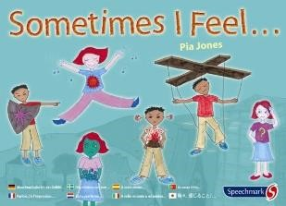 | Sometimes I Feel...Pia Jones  A resource of cards to help children identify and explore feelings. | Speechmark Publishing Ltd.  Outside the Box Learning Resources Ltd.  Jigginstown Commercial Centre,  Newbridge Rd,  Naas,  Co Kildare   045 856344  info@outsidetheboxleaning.com
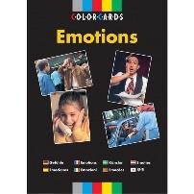 | Colorcards Emotions  A resource of cards that have been designed to enable students to focus on the subject  of emotions more easily. The photographs are divided into three groups, each with a different emphasis i) individual people ii)  Difficult situations iii) enjoyable situations | Eoin O Riordan Educational  Resources  83 Woodstock,  Kilcoole,  Co. Wicklow   087 2362757  Eor.resources@gmail.com
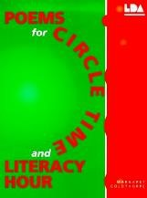 | Poems for Circle Time | Margaret Goldthorpe
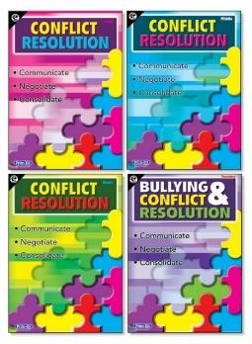 | Conflict Resolution  An comprehensive 4-book photocopiable series to incorporate into your SPHE lesson plans that provides conflict resolution  techniques for dealing with conflict issues in the classroom. Posters to compliment the books also available. | Prim-Ed publishing  http://www.prim-  ed.com/webshop/root/SPHE/Conflict  -Resolution
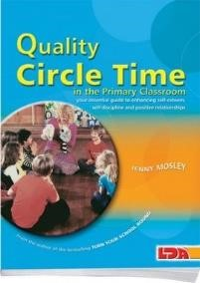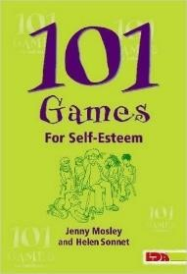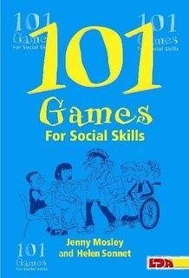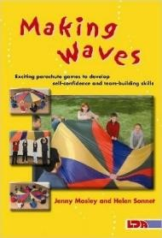 |  | Books by Jenny Mosley  Quality Circle Time  More Quality Circle Time  101 Games for Self Esteem  101 Games for Social Skills  101 Games for Better Behaviour  Making Waves (parachute games)

Interactive websites to support the implementation of SPHE

Website
www.pdst.ie
Contains SPHE teaching and planning resources. SPHE curriculum Glance Cards available from http://ppds.pdst.ie/images/stories/curriculum_pages/sphe/spheallstrandunits.pdf
http://www.education.ie/en/Schools-Colleges/Services/National-Educational-Psychological-Service-NEPS/Resources-Publications.html Contains support materials, publications and resources available from the National Educational Psychological Service.
http://www.cccoe.net/social/skillslist.htm
Outlines simple tips for the development of social skills in middle classes.
http://www.nicurriculum.org.uk/key_stages_1_and_2/areas_of_learning/pdmu/living_learning_together/home.a sp
SPHE resources for Northern Ireland Curriculum. This subject is called personal development and mutual understanding. This resource is presented at seven levels. Active learning is the central methodology used in this resource.
www.healthinfo.ie
A HSE Health promotion website where teachers/practitioners can register as professionals and order resources online. The service is free. The SPHE post holder should register here. Materials available include, safety DVDs, Busy Breaks DVD and Books and much more.
www.actionforhealthykids.org
Action for Healthy Kids is your “go to” place for information, research, reports, facts and supporting materials to help you help a school become a healthier place – and to help our kids be healthier. Not a lot of ready to use classroom materials.
www.agriaware.ie
Agriaware has a number of ongoing initiatives at primary level, many of which are intrinsically linked to the SPHE curriculum.
www.dentalhealth.ieThe Dental Health Foundation website contains information on all the following areas: 1) The Healthy Mouth, 2) Caring for Your Children’s Teeth 3) The Link Between Oral Health and General Health 4) Oral Health Care Products 5) Information and Education on Fluorides. It also contains “Mighty Mouth” programme for infants and accompanying teachers manual.
www.fooddudes.ie
The website for the Healthy eating programme that many schools around the country have participated in. Contains curriculum links to SPHE and other subjects as well as posters and work cards that can be downloaded free of charge.
www.ndc.ieThe National Dairy Council has re-launched the School Milk and Dairy Programme with a new website called the Fresh Milk Club. The Fresh Milk club website is dedicated to schools, parents and pupils. The site also contains information sheets and worksheets related to dairy products.
www.sparky.orgThis well known site covers all subjects. It contains background material, lessons and project materials for SPHE and is delineated into the four class levels. It also contains lessons on internet safety for middle and senior classes.

Further documents to assist planning for teaching and learning in SPHE

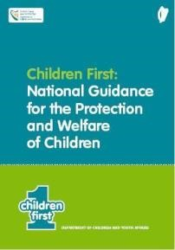 | Children First Guidance  The revised Children First: National Guidance for the Protection and Welfare of  Children sets out a number of key messages relating to the duty to protect children. Among these are that the safety and welfare of children is everyone’s responsibility, that children will have safer lives where everyone is attentive to  their wellbeing and that people who work with children across a range of areas  understand their responsibility for safe practice and the reporting of concerns. It provides greater clarity and guidance for individuals and organisations in  identifying and responding appropriately to child abuse and neglect and sets out specific protocols for Social Workers in the Child and Family Agency, Gardaí and  other front line staff in dealing with suspected abuse and neglect of children. Available from www.pdst.ie and www.dcya.ie
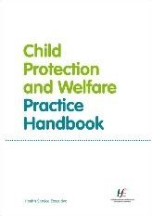 | The Child Protection and Welfare Practice Handbook  The Child Protection and Welfare Practice Handbook has been written as a practice resource to support best practice in frontline Child Protection and  Welfare work. It is based on the Children First National Guidelines 2011 and sets out the key issues in the areas of recognising abuse, responding to referrals, risk factors, assessment, planning and intervention. Available from www.pdst.ie and www.tusla.ie
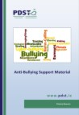 | Anti-Bullying Prevention and Intervention Strategies  This PDST anti-bullying support material is intended to be used by schools to assist them in the implementation of the Department of Education and Skills Anti-Bullying Procedures for Primary and Post-Primary Schools (2013). Available from www.pdst.ie
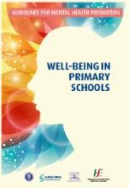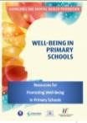 | Wellbeing in Primary Schools  These Guidelines have been developed by the National Educational Psychological  Service in consultation with advisors from the Department of Education and  Skills, the Health Service Executive, the Department of Health and the Department of Children and Youth Affairs. They provide practical guidance on how primary schools can promote mental health and well-being. A document outlining resources for promoting wellbeing in schools is also available. Available from www.education.ie
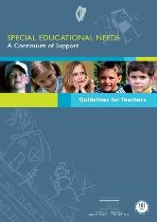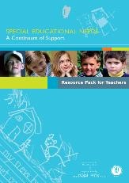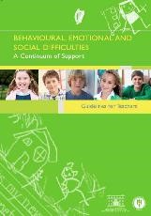 |  | Continuum of Support Documents  The focus of the guidelines is on the process schools and teachers may use to identify and cater for the special  educational needs of individual pupils in proportion to the  impact of those needs on their learning and socialisation.  The process moves from simple classroom based interventions to more specialised and individualised interventions.  Available from www.education.ie
Circular 22/2010 – SPHE best practice guidelines for primary schools
Circular 65/2011 – Child Protection Procedures for primary and post-primary schools
Circular 43/2013 – Anti-bullying Procedures for primary and post-primary schools

