At St. David’s N.S., children receive a daily maths lesson.  As a basis for planning teachers use the Maths Curriculum, School Policy on Maths, Mental Maths, Mathemagic, Maths Matters and Work it Out.  The purpose of this booklet is to outline the various calculation methods that children are taught as they progress through the school. Many of them look different to the methods that you may have been taught in your primary school days.  As children progress through the school, they are building up a bank of strategies that can be applied when appropriate. Each strategy can be refined or extended to suit the calculation needed.  We hope the explanations and examples of strategies will help you to assist your child at home.  Included in the booklet are also various ideas and suggestions for maths activities that you can enjoy doing with your child in the world away from school. It is not an exhaustive list and you will doubtlessly have more ideas of your own.  1  Real Life Problems  - Go shopping with your child to buy two or three items. Ask them to work out the total amount spent and how much change you will get.  - Buy items with a percentage extra free. Help your child to calculate how much of the product is free.  - Plan an outing during the holidays. Ask your child to think about what time you will need to set off and how much money you will need to take.  - Use a bus or train table. Ask your child to work out how long a journey between two places should take. Go on the journey. Do you arrive earlier/later than expected? By how much?  - Help your child to scale a recipe up or down to feed the right amount of people.  Getting children involved in real situations where they are using mathematical skills is motivating and stimulating.  SHAPE AND MEASURE  - Choose a shape of the week. Look for this shape in the environment. Ask your child to describe the shape to you.  - Play ‘guess my shape’. You think of shape. Your child asks questions to try to identify it but you can only answer ‘yes’ or ‘no’.  - Hunt for right angles around your home. Can your child spot angles that are bigger or smaller than a right angle?  15  MULTIPLICATION  Children are taught to understand multiplication as repeated addition. A good knowledge and quick recall of times tables is essential to children’s mathematical progress.  When learning their tables, children are taught to look for patterns.  Children are taught to recognize the revisable effort so that they know 6 x 2 is the same as 2 x 6. They are also taught the relationship with division.  Practicing Number Facts:  8 x 4 = 32 32 ÷ 4 = 8  4 x 8 = 32 32 ÷ 8 = 4  7  MATHS PROBLEM SOLVING STRATEGIES  R U M O R S  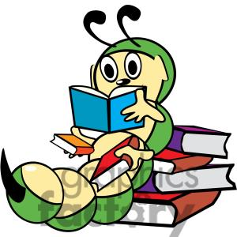  R Read the problem carefully  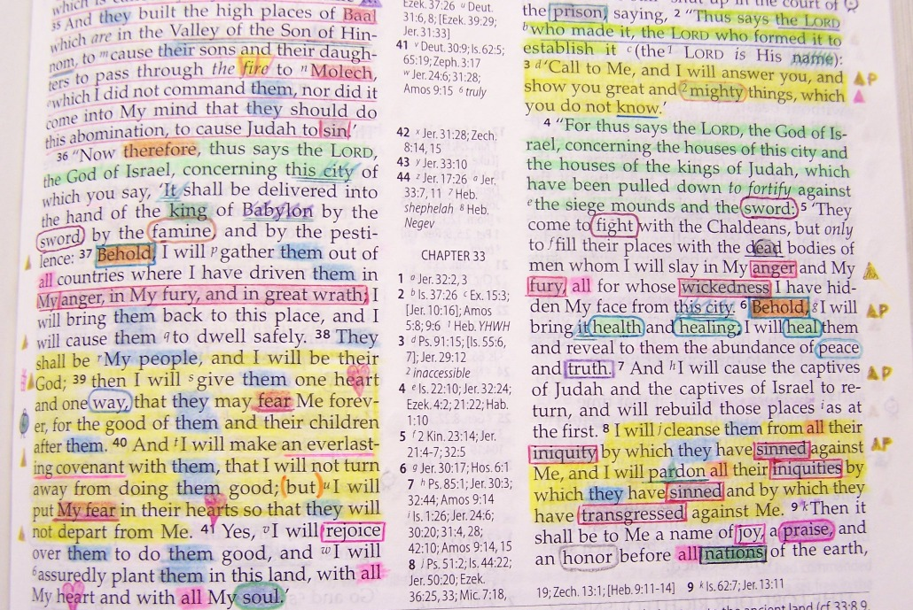  U Underline the clue words / the facts  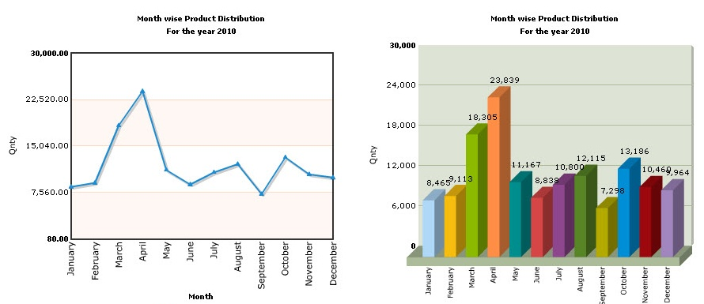  M Make a drawing / graph / pattern  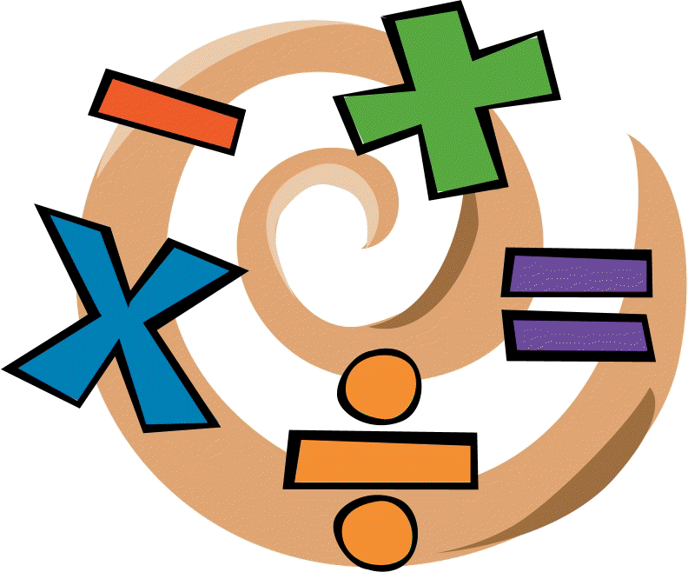  O Operation + - ÷ x  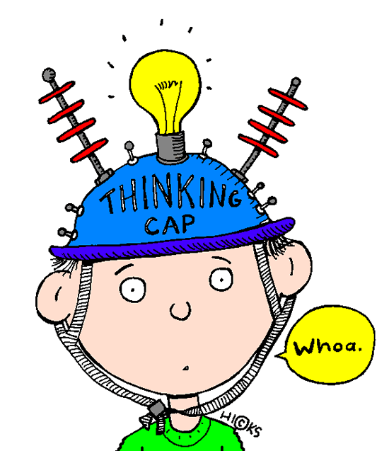  (make a number sentence)  R Recheck and reflect.  (Is the answer sensible?)  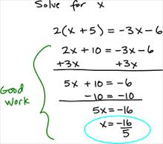  S Show all your work.  9  ADDITION  Children are taught to understand addition as combining sets and counting on. 12 + 5 = 17. Start at 12. Count on 5  Calculations are put into practical contexts so that the children see the relevance of the method they are learning.  6 + 5 =◻ Six people on a bus. 5 more people get on at  the next stop. How many are on the bus now?  Practicing Number Facts:  4 + 3 = 7 7 - 3 = 4  3 + 4 = 7 7 - 4 = 3  Children are taught the relationship with subtraction  5  NUMBERS  A lot of emphasis in numeracy teaching is placed on using mental calculations where possible, using jolting to help support thinking.  It is important that children are secure with number operations and have a good understanding of place value (tens, hundredths, etc)  NUMBER LINES  Number lines are a very important tool used in all calculations. Children are introduced to them right from their first year of school.  Number line can take many forms and are used in a huge variety of ways to help develop children’s understanding of number.  Children make jumps up and down on number line to help them solve a math’s problem.  -3 -2 -1 0 1 2 3  Draw a blank number line to help calculate how much change from 50c after spending 36c  30 36 40 50  3  SYMBOLS  = the equals sign does not always signal ‘the answer comes next’: equals means ‘the same’ or equivalent.  > greater than  < less than  └ right angle  ┴ perpendicular  ║ parallel  6 = 6/1 = 6.0 . 7 = 7/1 = 7.0 etc  11  COUNTING IDEAS  Practise chanting the number names. Encourage your child to join in with you. When they are confident, try starting from different numbers – eg 4, 5, 6… Also try counting backwards.  Sing number rhymes together – there are lots of commercial CD’s available.  Give your child the opportunity to count objects (coins, pasta, shapes, buttons, etc) Encourage them to move each object as they count them.  Count things you cannot touch – window panes, jumps, claps, oranges in a bag.  Play games that involve counting – eg snakes and ladders, dice games.  Look for numerals in the environment – eg car number plates  Make mistakes when chanting, counting or ordering numbers. Can your child spot what you have done wrong?  Chose a number of the week e.g. 5. Practice counting in 5’s, up to 5, on from 5, collect groups of 5 items.  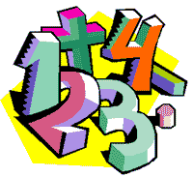  13  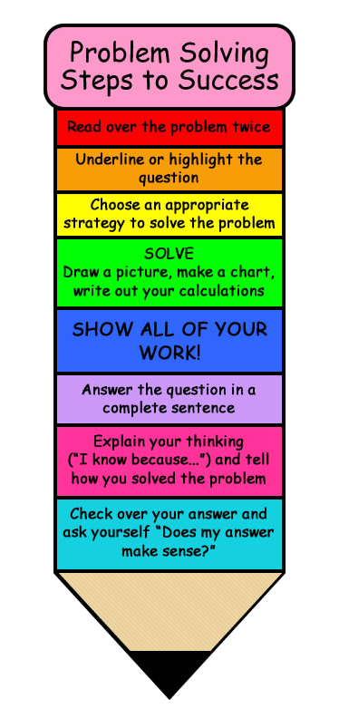  RHYMES TO HELP TEACHING NUMBER FOR INFANTS  A tall straight stick will make a 1.  Writing numbers can be fun!  Around and back, watch what you do,  As you make number 2!  Go round and round – what can it be??  This is known as number 3!  Down, across, then bolt the door  This is how we make a 4!  Number 5 has a fat round tummy  With his hat on, he looks funny!  Pull the line down, then go round  It’s the number 6 we’ve found!  Across the top and down we go  Number 7 is on show!  Start with an S but do not wait,  Go back to the top and make an 8!  Draw an oval then a line  Now you’ve made the number 9!  Round and round your pencils go  This is how we make a zero!  Make 1 first, and zero then  This is how we make a 10!  17 | 18  MATHS LANGUAGE  - Addition Tables:  We say “two and one are three, two and two are four”  We always start with the number of the table we are teaching.  - Subtraction:  We say “six from eight leaves two, six from nine leaves three”. In subtraction sums we use decomposition and regrouping throughout the school.  - Subtraction with Regrouping.  When subtracting all pupils, parents and teachers  are requested to use the following wording:  T U  5 1  - 2 3  (5 1 take away 23 or 51 subtract 23).  We begin with the unit side.  RULE: ALWAYS START AT THE BOTTOM  3 from 1 we cannot do. T U  So we bring over a ten from the tens side 5 1  How many tens do we have now? 4 -2 3  How many units do we have now? 11  REMEMBER BEGIN WITH THE UNITS  3 from 11. What does that leave? T U  3 from 11 leaves 8 5 1  (Now subtract the tens). -2 3  2 from 4 – What does that leave? 2 8  2 from 4 leaves 2.  We had 51 and we took away 23  Now what have we left? We have 28 left.  - Multiplication Tables: We say “five twos are ten, five threes are fifteen”.  - Division: We say “two goes into six three times” or “two into eight goes for times, two into ten goes five times”.  4  2 x 2 = 4  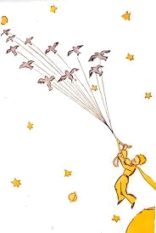  2 x 3 = 6  2 x 4 = 8  2 x 5 = 10  2 x 6 = 12  2 x 7 = 14  2 x 8 = 16  2 x 9 = 18  3 x 3 = 9  3 x 4 = 12  3 x 5 = 15  3 x 6 = 18  3 x 7 = 21  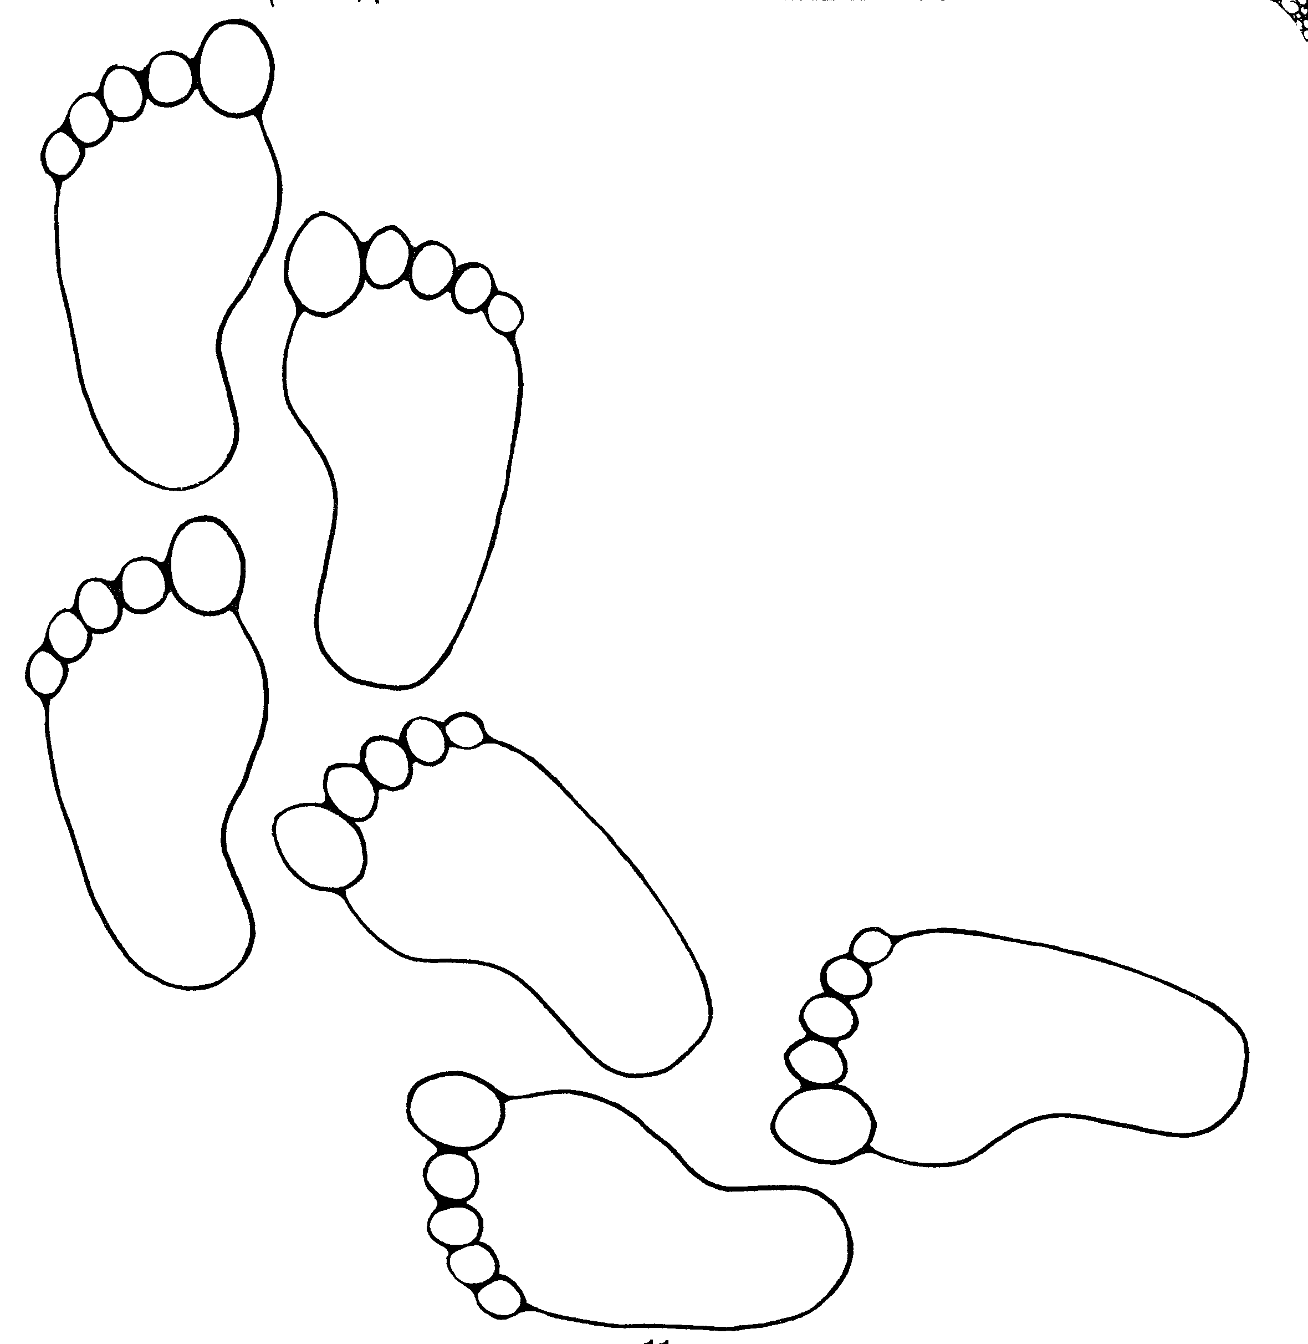  3 x 8 = 24  3 x 9 = 27  4 x 4 = 16  4 x 5 = 20  4 x 6 = 24  4 x 7 = 28  4 x 8 = 32  4 x 9 = 36  5 x 5 = 25  5 x 6 = 30  5 x 7 = 35  5 x 8 = 40  5 x 9 = 45  6 x 6 = 36  6 x 7 = 42  6 x 8 = 48  6 x 9 = 54  7 x 7 = 49  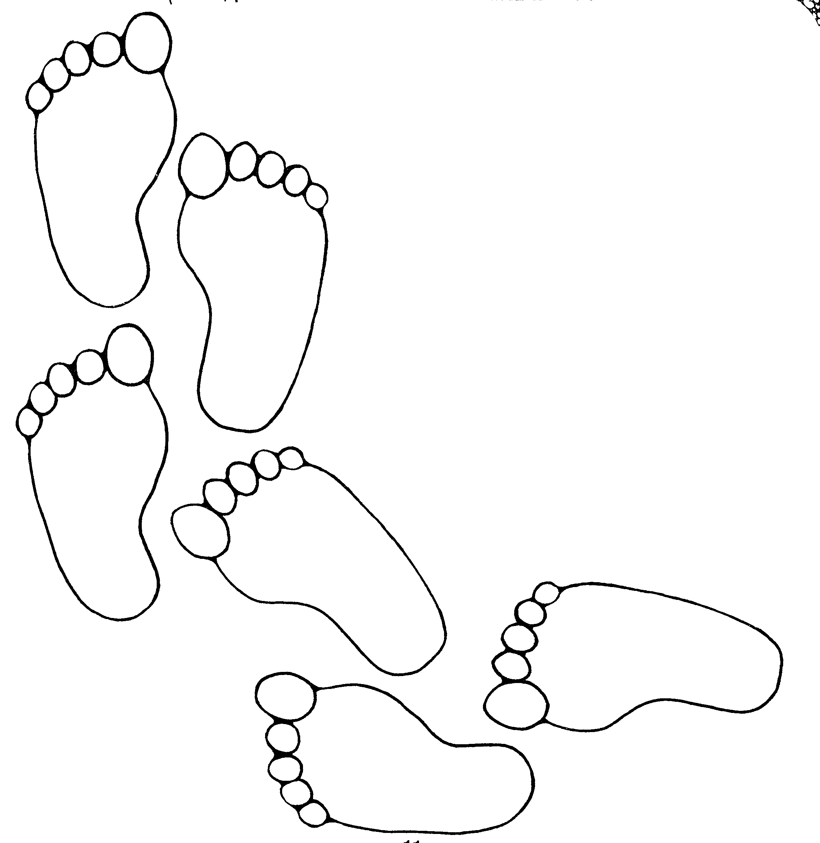  7 x 8 = 56  7 x 9 = 63  8 x 8 = 64  8 x 9 = 72  9 x 9 = 81  KNWS for Math Problem Solving  Discussing the efficiency and suitability of different strategies is an important part of maths lesson. Explaining strategies and processes orally helps to develop the use of appropriate mathematical vocabulary.  10  PRACTICING NUMBER FACTS  - It is important children learn number bonds to 10 eg 4 + 6 = 10 and number bonds to 20 eg 14 + 6 = 20 by heart.  - Play ‘ping pong’ to practice components with your child. You say a number and they reply with how much more is needed to make 10, 20, 100 or 1000. Encourage your child to answer quickly without counting or using fingers. Eg make 100 you shout 40 they shout 60.  - Throw two dice. Ask your child to find the total of the numbers (+), the difference between them (-) or the product (x).  - Use a set of playing cards (without the picture cards). Turn over two cards and ask your child to add or multiply the numbers. If they answer correctly, they keep the cards. How many cards can they collect in two minutes?  - Play 24 with a pack of playing cards using all of them. You need 4 players, each puts a card down and first one to make 24 using any or all of the 4 operations and using all or some of the cards. First one to make number keeps all the cards. Eg you put down a Jack, 2 hearts, 7 spades and 2 clubs. You could say 2 x Jack add 2 hearts.  - Play Bingo. Each player chooses five answers (e.g. numbers to 10 to practice simple addition, multiples of 5 to practice the five times table, etc) Ask a question and if a player has the answer, they can cross it off. The winner is the first player to cross off all their answers.  - Give your child an answer. Ask them to write as many number sentences as they can with this answer. You could just ask for addition sentences or any type of calculation.  - Give your child a number fact: eg 5 + 8 = 13. Ask them what else they can find out from this fact: 50 + 80 = 130. 8 + 5 = 13, 13 – 8 + 5, 130 – 50 = 80, etc.  - Look out for car number plates. What is the number on the plate? What is this to the nearest 10 or 100 or 1000? How many more would  you need to reach the next multiple of 10, 100, 1000?  - Make up rhymes together to help your child remember tricky times tables.  - Look for symmetrical objects. Help your child to paint or draw symmetrical pictures/patterns.  - Make a model using different boxes/containers of different sizes. Ask your child to describe their model to you  - Practise measuring the lengths and heights of objects in metric measurements. Help your child use different rulers or tape measures correctly. Encourage them to estimate before measuring. Compare measurements in metric and imperial.  - Let you child help with the cooking. Help them to measure ingredients accurately. Talk about what each division on a scale represents.  - Choose some food items out of the cupboard. Try to put the objects in order of weight by feel alone. Then check by looking at the weights on the packets.  - Practise telling the time with your child. Use both digital and analogue clocks. Ask your child to be a ‘timekeeper’- e.g. tell me when it is half past four because we are going swimming.  - Use a stop clock to time how long it takes to do everyday tasks – e.g. how long does it take to get dressed. Encourage your child to estimate first.  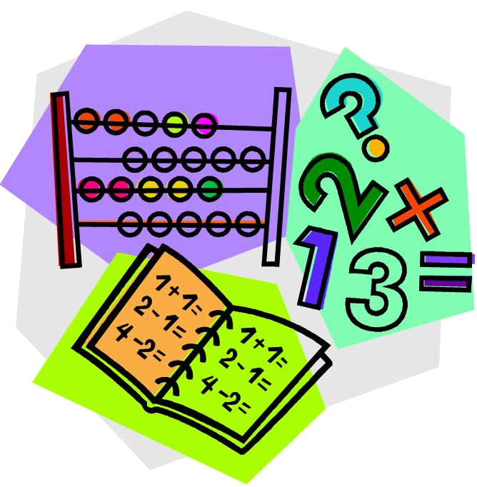  - Use a TV guide. Ask your child to work out the length of their favourite programmes. Can they calculate how long they spend watching TV each day/week?  16  DIVISION  Children are taught to understand division as sharing and grouping. Multiplication and division are interlinked. Knowing multiplication tables means you know division tables.  Practicing Number Facts:  30 ÷ 6 = 5 6 x 5 = 30  30 ÷ 5 = 6 5 x 6 = 30  8  SUBTRACTION  Children are taught to understand subtraction as taking away (counting back) and finding the difference (counting on/up).  Practicing Number Facts:  7 - 3 = 4 4 + 3 = 7  7 - 4 = 3 3 + 4 = 7  Children are taught the relationship with addition.  Knowing addition tables means you know subtraction tables.  6  ST. DAVID’S N.S.    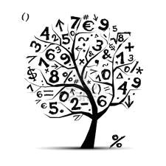  A Booklet for Parents and Children  GUESS  &  CHECK  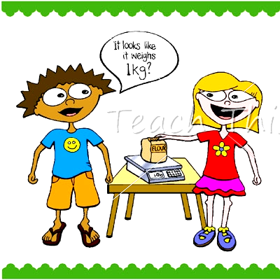  2
  X
  32
  8 | 4
  7
  4 | 3
  Tth | Th | H | T | U | ● | 1/10 | 1/100 | 1/1000
  Tens of thousands | Thousands | Hundreds | Tens | Unit | ● | One tenth | One hundredth | One thousandth
  0 | 1 | 2 | 3 | 4 | … | 10
  One, two, three, four, five  Once I caught a fish alive  Six, seven, eight, nine, ten  Then I let him go again.  Why did you let him go?  Because he bit my finger so.  Which finger did he bite?  This little finger on the right. | One, two  Buckle my shoe  Three, four  Knock at the door  Five, six  Pick up sticks  Seven, eight  Lay them straight  Nine, ten  A big fat hen.
  Peter works with one hammer,  One hammer, one hammer.  Peter works with one hammer,  All day long.  (bang one fist throughout)  Peter works with two hammers…  (bang two fists)  Peter works with 3 hammers…  (bang two fists and one foot)  Peter works with 4 hammers…  (bang two fists and two feet)  Peter works with 5 hammers  (bang two fists, two feet and nod head)  Peter very tired now  (stop and rest)  Peter’s wide awake now  (repeat actions quickly) | Ten jolly people  Ten jolly people waiting at the stop.  Along comes a bus, and one goes hop,  into the bus and off they go.  Nine jolly people waiting at the stop…  (Actions: hold up ten fingers and put  Them down one by one)
  Five little seashell, lying on the shore,
  Swish went the waves and then there were four.
  Four little seashells washed by the sea
  Swish went the waves and then there were three
  Three little seashells where the breeze blew
  Swish went the waves and then there were two
  Two little seashells, lying in the sun,
  Swish went the waves and then there was one.
  One little seashell on the shore alone
  Whispered “shhhhhh” as I carried it home.
  K
  What do I KNOW from the information stated in this problem?
  N
  What information do I NOT need in order to solve this problem?
  W
  WHAT exactly does this problem ask me to find?
  S
  What STRATEGY or operation will I use to solve this problem?
  ÷
  ÷
  30
  5 | 6
  -
  7
  4 | 3

